**What is Web development?**

**Web Development** is the work that goes into building and maintaining these amazing websites that we use in our daily life. Web developers are professionals who give in hours of work and their services to build websites that entertain us, websites that help us in our daily works and websites for other organizations that handle a lot of data, e.g., YouTube, Amazon and websites that improve the digital banking experience like PayPal etc.

**Web Design VS Web Development:**

When we surf the internet, we are actually seeing two different aspects of a website. One is web design which refers to the designing aspect of the website, how it will look, what brand color and identity it will have, how it will appeal the viewers and how it will attract new audience. Whereas, the other part is known as web development. In this part web engineers or teams of web engineers sit down to bring the designed idea to real life for the people to experience. In this portion the questions of how the website will behave, how efficient it will be, what kind of security will it have and how it will be maintained are answered.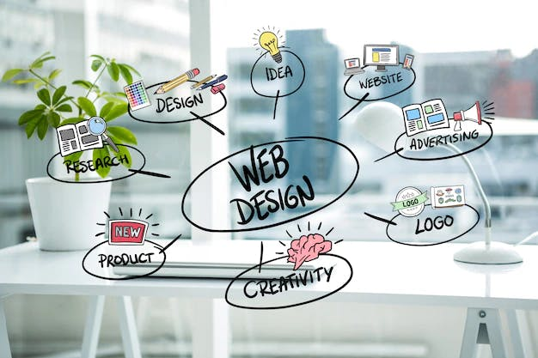

**Components of Web development:**

In this article I will focus on delivering the content that will enhance your knowledge about web development. Web development is further categorized into two parts i.e., Front-end Web development and Back-end Web development.

**Front-end Web Development:**



Front-end web development is the process that focuses on the visual details of the website. It is the user side of the website we experience. When web designers approve of a specific design for a website the project is then passed onto front-end web developers to code the idea because whatever we see on our computers is in fact the result of coding and programming. After the coding is done the website is ready to be used. Front-end developers work with technologies like HTML, CSS and JavaScript and their frameworks to build the front end of a website.

**Back-end Web Development:**

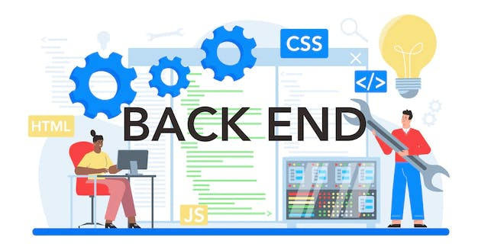But the work here to produce a website is not completed because we still need to interact with the website, store the data that is or that maybe entered into the website, and make sense out of the data so that it is usable. This is where back-end web development comes in. Back-end web development deals with the server side of the website. In order to make the website work back-end web developers’ program in such a way that server, application (the website), and data base can interact with each other in efficient way and that the data can be stored, changed and sent back to user side for further process. PHP, Ruby, Python, Java and .Net are used to build the application and tools like SQL, Oracle and others are used to tackle the data handling tasks.

**Full Stack Developers:**

There are often situations when back-end developers have to deal with html and CSS and front-end developers need to be familiar with technologies like python and Php etc. This is where the full-stack development steps in. Full stack developers are jacks-of-all-trades. The concept of full stack development is easy to grasp as it includes the knowledge of both ends of development.

**Why learn Web Development:**

Web development is a great hard skill to learn as websites are now a critical component for any business to stay competitive. The internet contains more than 1.8 billion websites and counting. Meaning great opportunities for web developers and job security for them. Web developers have a great potential to earn a lot even if they sit at home.